|  |
| --- |
| 17419238 |
| Assignment 1: Web Development |
| https://triantus.github.io/csy1018-assign1 |
|  |
| **Antonios Triantafyllidis (17419238)** |
| **[Pick the date]** |

Contents

index.html design 2

bio.html design 4

cv.html design 4

contact.html design 6

Sources used 9

Introduction

**This document shows, step by step, the progress made on the Web Development Assignment 1, from the beginning to the end. I was pretty ambitious at the beginning and confident that this would end in less than 10 hours work but didn’t taken into account, the rest of the work in the other modules that I had to complete.**

**The initial idea for the website, is different than the one produced as you will see on the next chapters.**

Design

**First ideas that I had for the design, proved to be complex for the human-eye and for a simple CV-website. Below, is the first sketch that I made, pretty confident that I would build this website in a week at the time.**

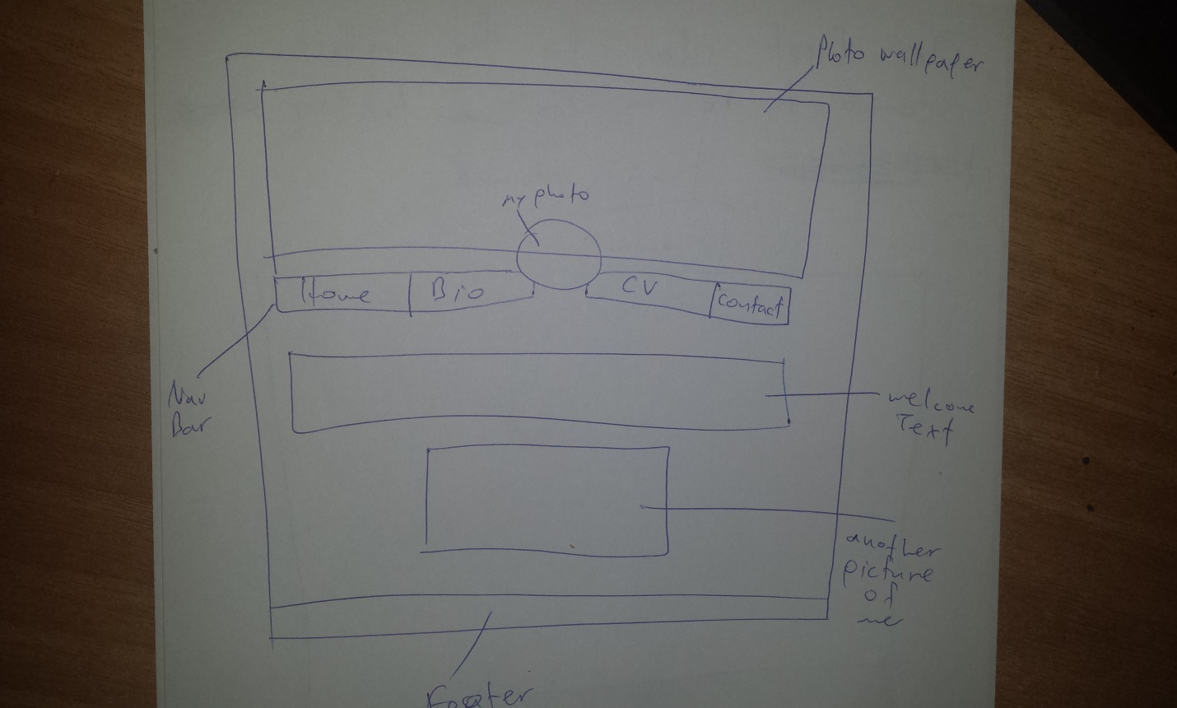

Figure 1

**I began to write the code, but this idea proved to be very time consuming for the burdening schedule that I had.**

**The thought after some brainstorming and some discussions with my colleagues, came up. Simplicity.**

**Simplicity was the key. Doesn’t make the user struggle to read, and it is beautiful if designed properly.**

# index.html design

**Figure 2, shows the design in my mind, and the sketch for the home page.**

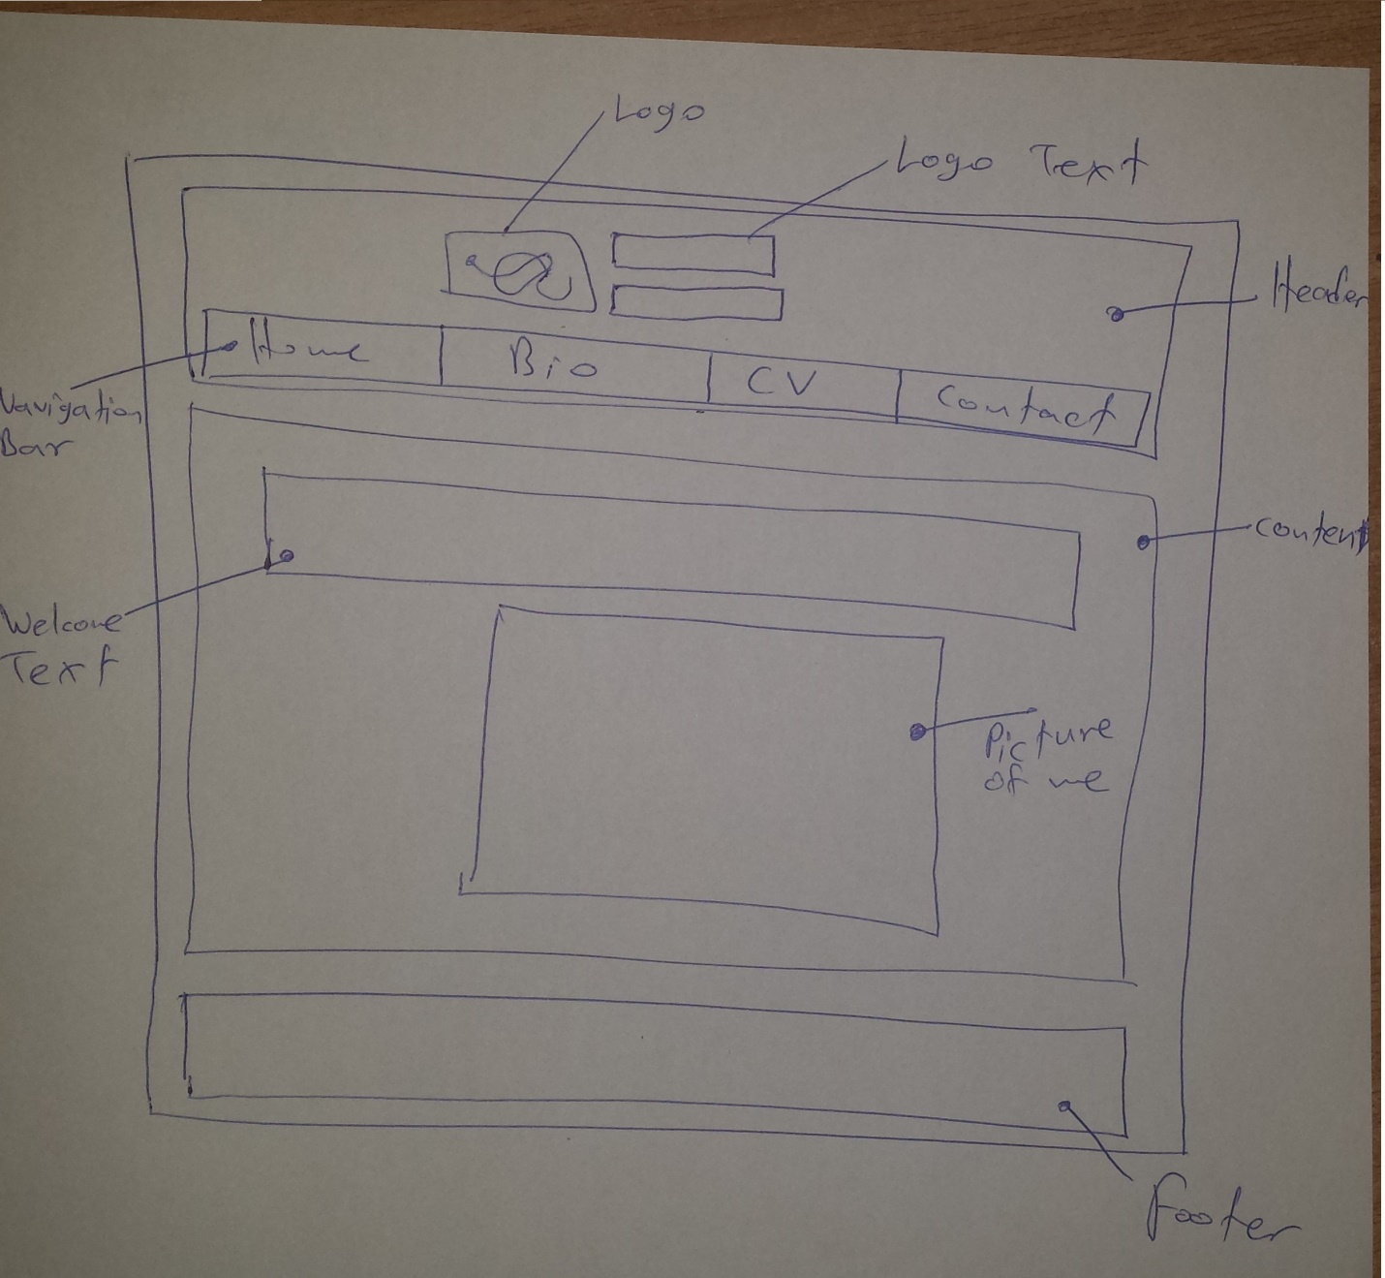

Figure 2

**Header and footer, will be the same in every page. Only the content will change. Like I said, simplicity.**

**The character I am going to make a bio for, is an imaginary character that I used to play in an online game. Any picture of him is not copyrighted since I was the one who captured them. (Unless the small letters of the game policy state otherwise.)**

# bio.html design

**Figure 3, shows my sketch for the bio page**

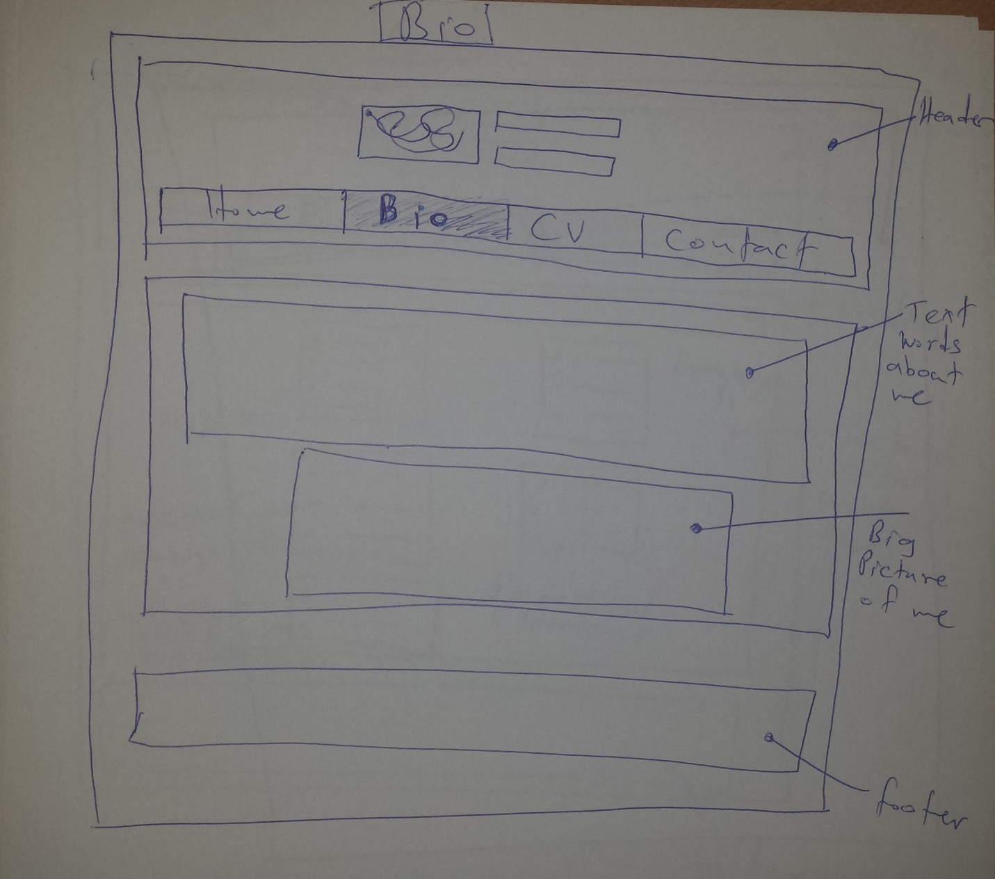

Figure 3 - Bio

# cv.html design

**Figure 4, shows my sketch for the cv page**

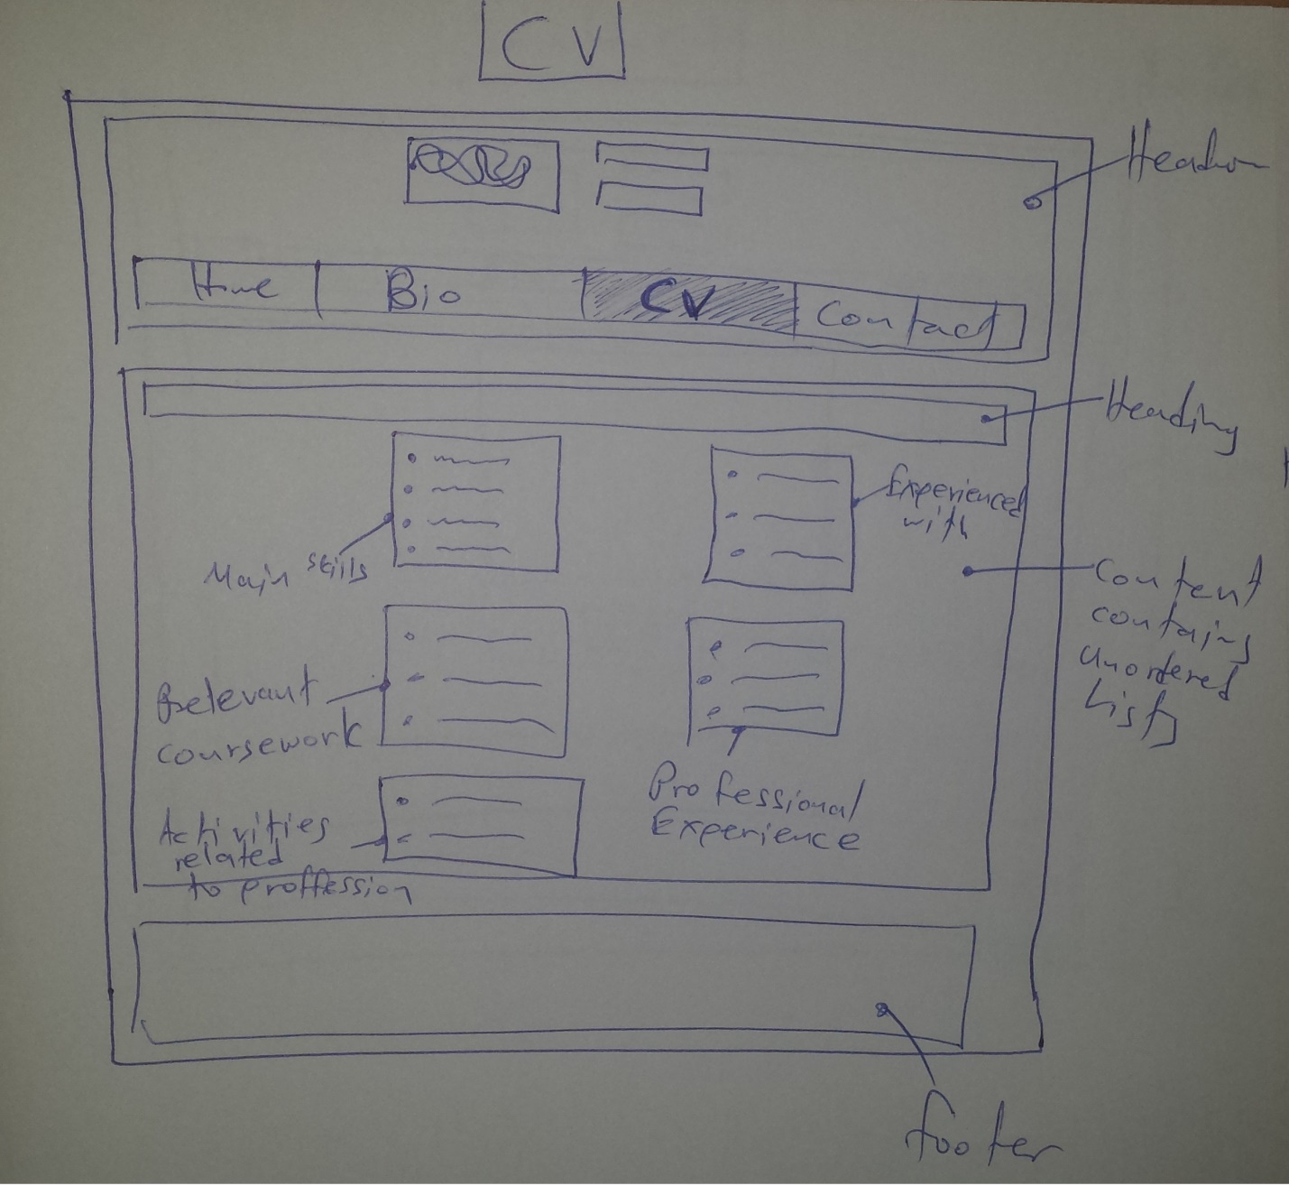

Figure 4 - CV

# contact.html design

**Figure 5, shows my sketch for the contact page**

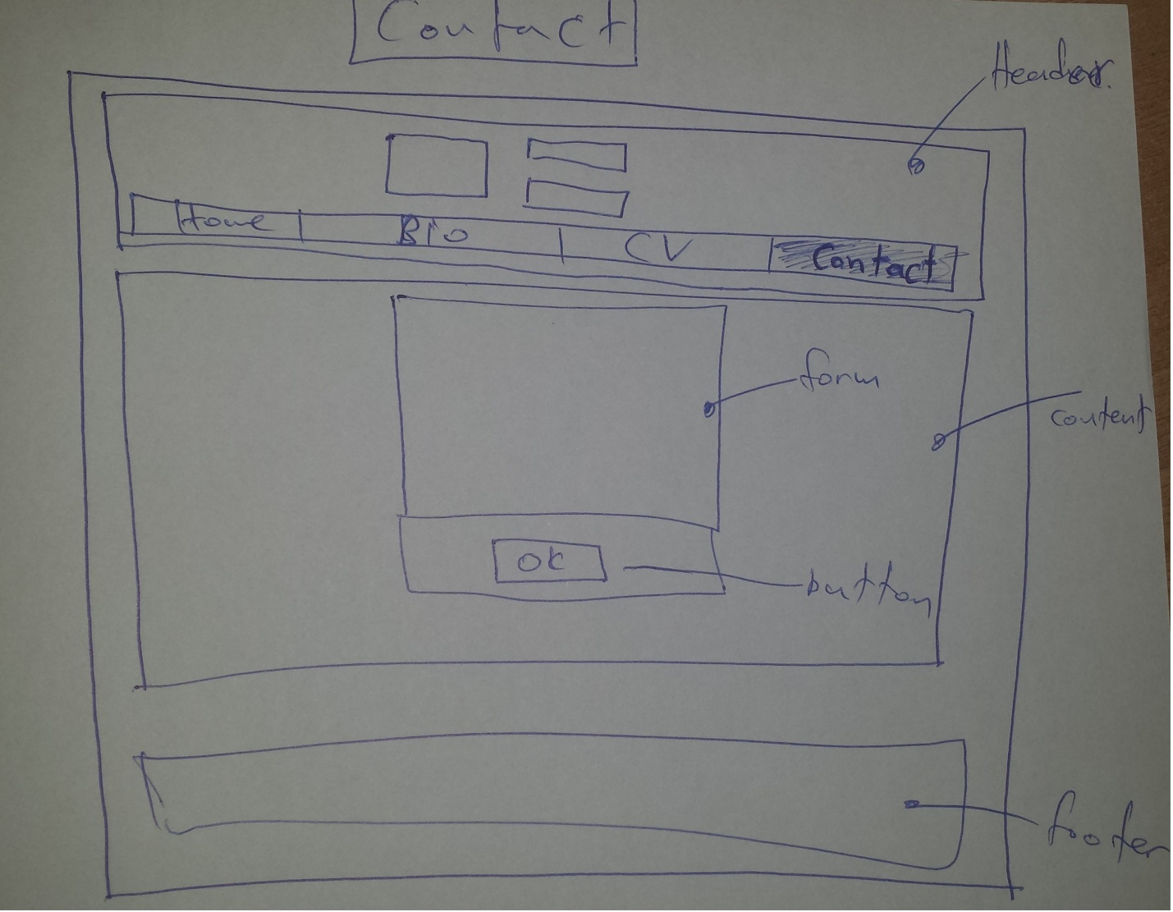

Figure 5 - Contact

**After coding everything, one of my colleagues mentioned that we had to have the logo on the left side; something that I had missed.**

**I altered the code some to achieve that, in every page. Inspired by Joel’s example site, I found the chance to create two pictures in the index page, under the welcome text that each was a link to another page. One to bio and the other to CV.**

**In figure 6, it is shown how the new index page would be:**

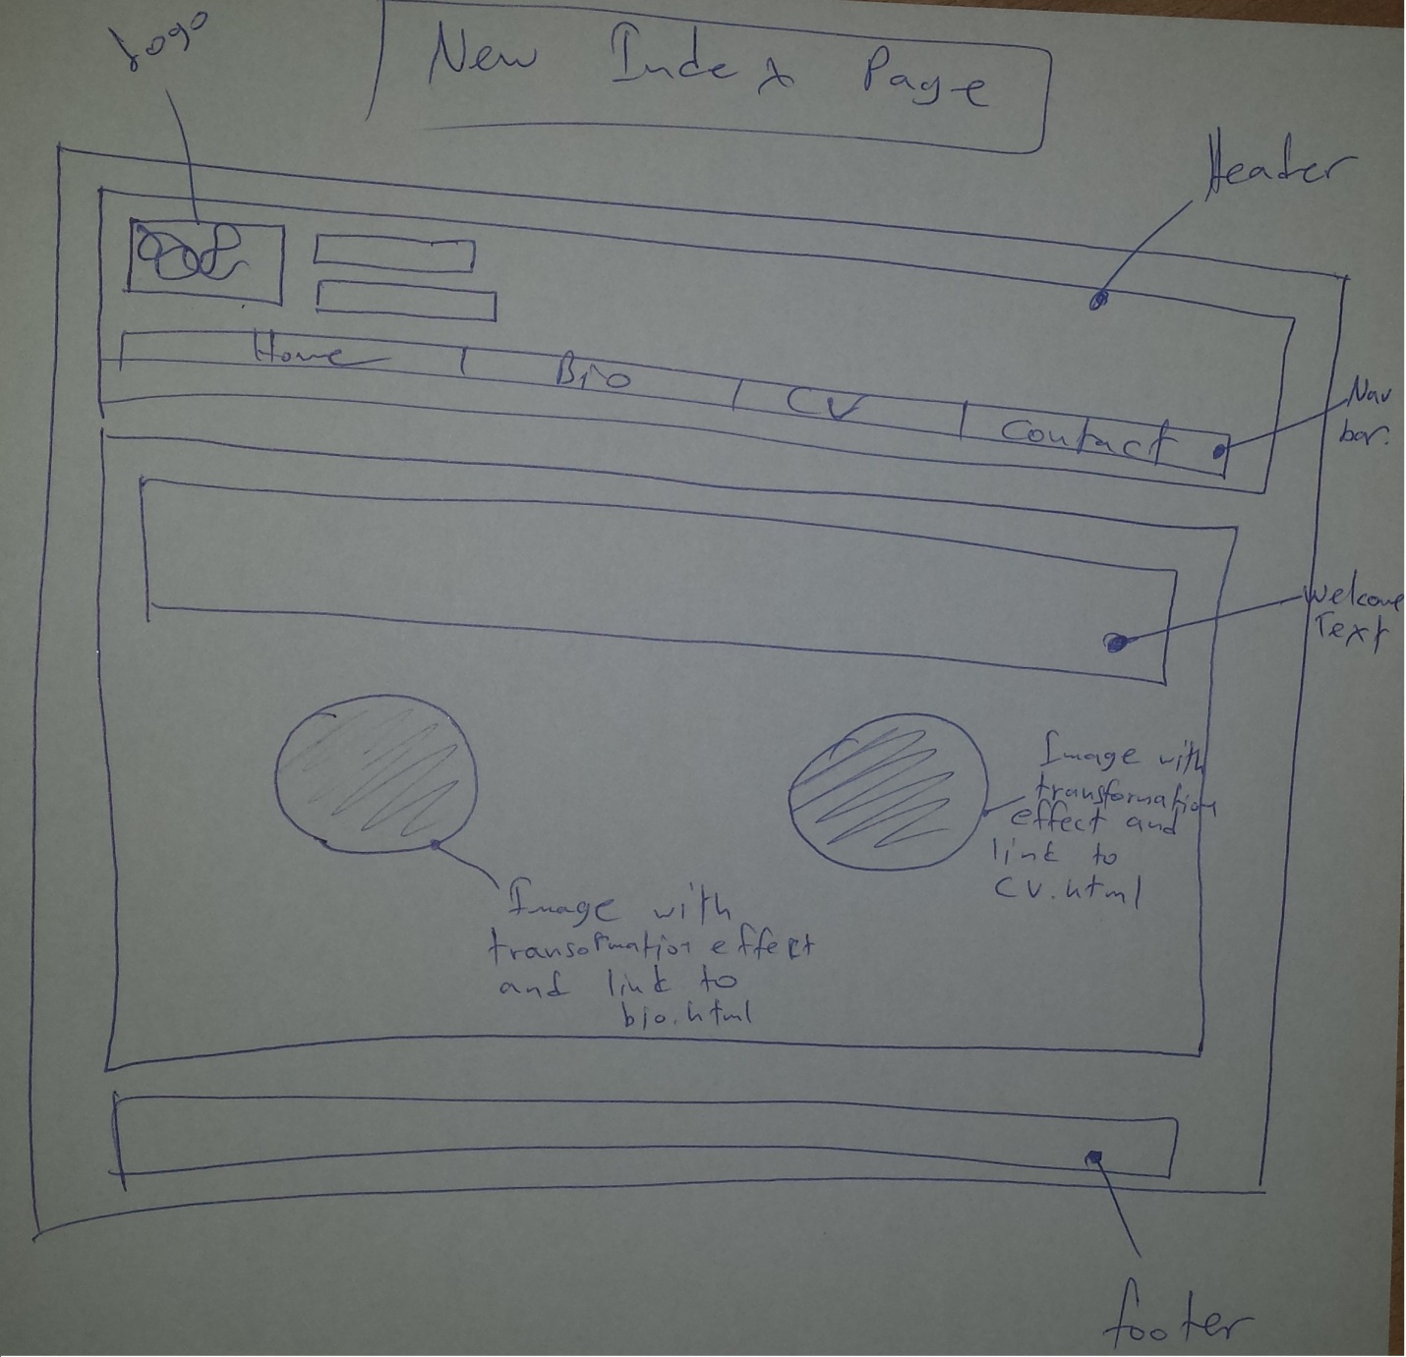

Figure 6 - Updated Index

**Logo is moved to the left, and there are two pictures under the welcome text. Both of those pictures have CSS transformation effect when hovering over either of them. The left links to bio.html and the right one, links to cv.html.**

Coding

**The in-depth analysis is in the comments of the code and in the comments of my commits in GitHub. In the README, the sequence of events is described, the brainstorming and what and not was included.**

* **Began with the index page and the css file. The building order continued as shown in the design.**
* **All pictures except the background that I took from Google, is custom and free.**
* **It took approximate 50 hours to complete the project.**
* **Gave a try to use flexbox a little bit before handing in the assignment but noticed no change when refreshed.**
* **Icons were not used for aesthetic reasons.**
* **The two images-links in the updated index page, could have a more complex effect when hovering that would indicate where each is linking, like text showing up when hovering. Not enough time for it.**
* **For logo text, Playfair Display google font was used.**
* **For welcome text in the home page, Raleway google font was used. Raleway was also used in the CV page.**
* **Favicon was used.**

**Had some discussions with my colleagues about the site, as it comes to div, the contact form and other elements concerning how something works and how it can be used/coded.**

**Also my tutor was a great help.**

Navigation Diagram

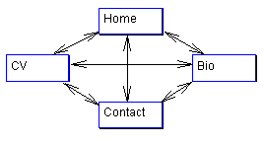

Validator Screenshots

The following screenshots were taken to prove that every page, is validated through the W3Schools validator services.

index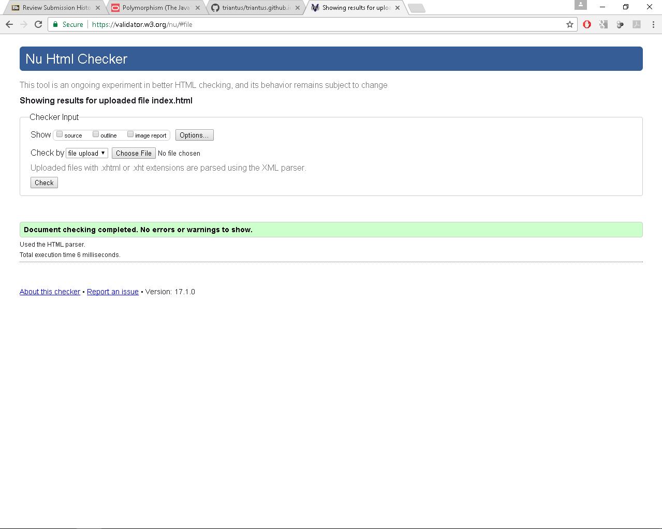

CV

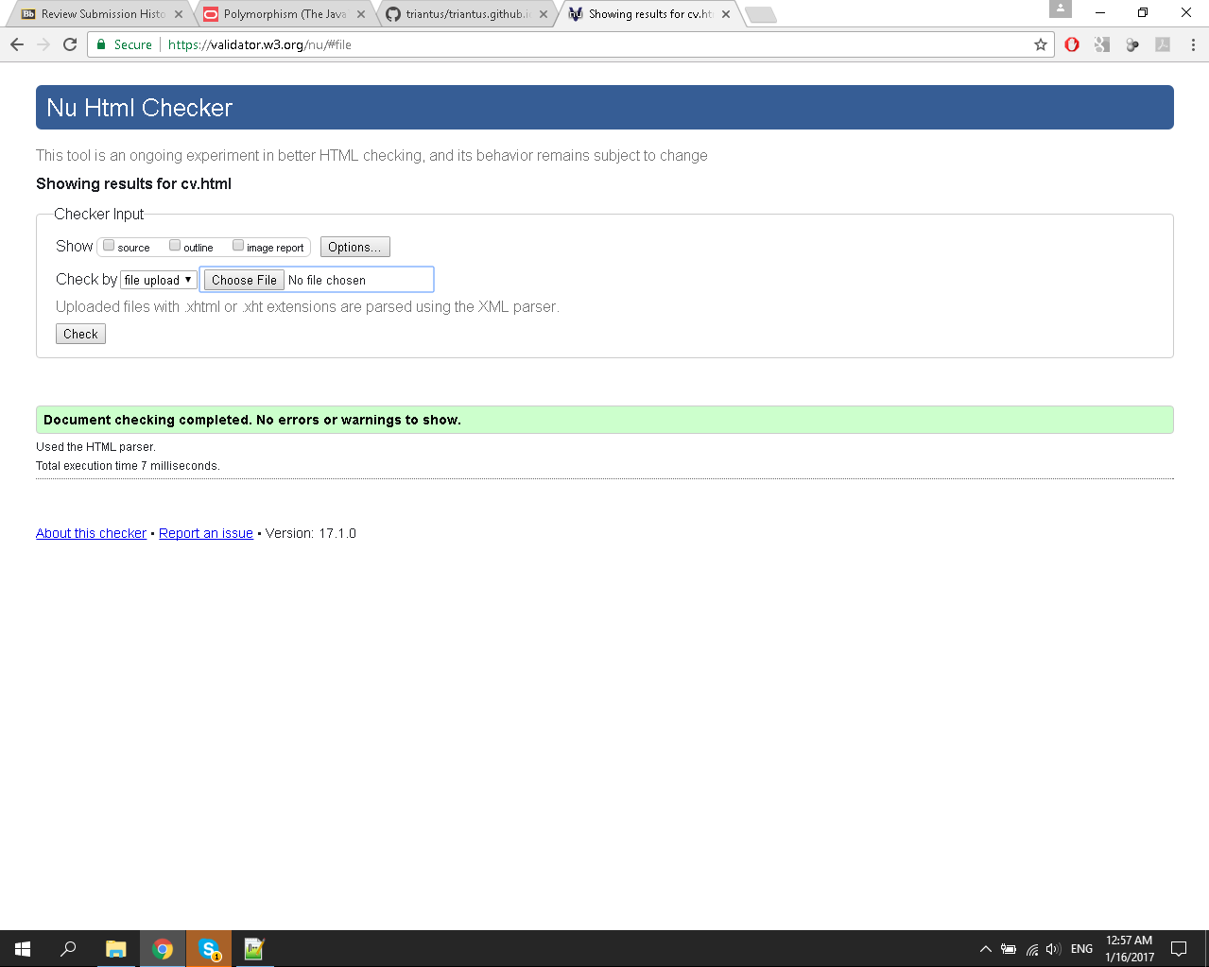

# Bio

## 

# Contact

# 

# mod.css

# 

# Sources used

**HTML pages were validated at:**

*The W3C markup validation service* (1994) Available at: https://validator.w3.org/ (Accessed: 10 January 2017)

**CSS File was validated at:**

*The W3C CSS validation service (1994) Available at: https://jigsaw.w3.org/css-validator/ (Accessed: 10 January 2017)*

**The site that helped me completely through the project development:**

**http://www.w3schools.com/**

**From here, I have read, and learned how to use transformation effect:**

*CSS3 transform property (no date) Available at: http://www.w3schools.com/cssref/css3_pr_transform.asp (Accessed: 04 January 2017).*

**Sources for contact form:**

*ContactF, 123 (2008) 123ContactForm makes it easy to build a great contact form: Just use our HTML contact form generator. Just sign up for free to get started. Available at: http://www.123contactform.com/html-contact-form/ (Accessed: 21 December 2016).*

*CSS forms (no date) Available at: http://www.w3schools.com/css/css_form.asp (Accessed: 21 December 2016).*

**For navigation bar, the light into the darkness was:**

*CSS navigation bar (no date) Available at: http://www.w3schools.com/css/css_navbar.asp (Accessed: 20 December 2016).*

**For favicon:**

*Dubost, K. (2005) How to add a favicon to your web site? Available at: https://www.w3.org/2005/10/howto-favicon (Accessed: 10 January 2017).*

# Final link to the site on GitHub

**https://triantus.github.io/csy1018-assign1**